University of Ibadan
Department of Computer Science
B.Sc. Degree Examination
First Semester 2022/2023 Academic Session
Database Systems (CSC 472)
Instruction: Attempt questions (1) and any two (2). Please state all assumptions. Time: 2.75 Hours
Question1:
The academic world is an interesting example of international cooperation and exchange. This problem is concerned with modeling of a database that contains information on researchers, academic institutions, and collaborations among researchers. A researcher can either be employed as a professor or a lab assistant. There are three kinds of professors: Assistant, associate, and full professors. The following should be stored:
• For each researcher, his/her name, year of birth, and current position (if any).
• For each institution, its name, country, and inauguration year.
• For each institution, the names of its faculties (e.g., Faculty of Law, Faculty of Business, Faculty of Computer Science, . . .).
• An employment history, including information on all employments (start and end date, position, and what Faculty).
• Information about co-authorships, i.e., which researchers have co-authored a research paper. The titles of common research papers should also be stored.
• For each researcher, information on his/her highest degree (BSc, MSc or PhD), including who was the main supervisor, and at what Faculty.
• For each professor, information on what research projects (title, start date, and end date) he/she is involved in, and the total amount of grant money for which he/she was the main applicant
- Draw an E-R model for the data described above. (12marks)
- Suppose there exist a relation Authoring defined as follows:
CREATE TABLE Authoring (
articleID INT REFERENCES Article (ID) ON DELETE SET NULL,
authorID INT REFERENCES Author (ID) ON DELETE CASCADE
)
Indicate which of the following statements are true, and which are not. (1mark each)
- If we try to delete a tuple from Authoring, the tuple is not deleted. Instead, articleID is set to NULL.
- If we delete a tuple from Authoring, any tuples in Author referred to by this tuple are also deleted.
- If we delete a tuple from Article, some attributes of Authoring may have their values set to NULL.
- If we try to insert a tuple into Author, with an ID that is not referred to in Authoring, the operation is rejected.
- If we try to insert a tuple into Authoring, with an ID that does not exist in Author, the operation is rejected.
- What is meant by functional dependency in the context of database normalization? (2 marks)
- Study the table provided below and do the following:
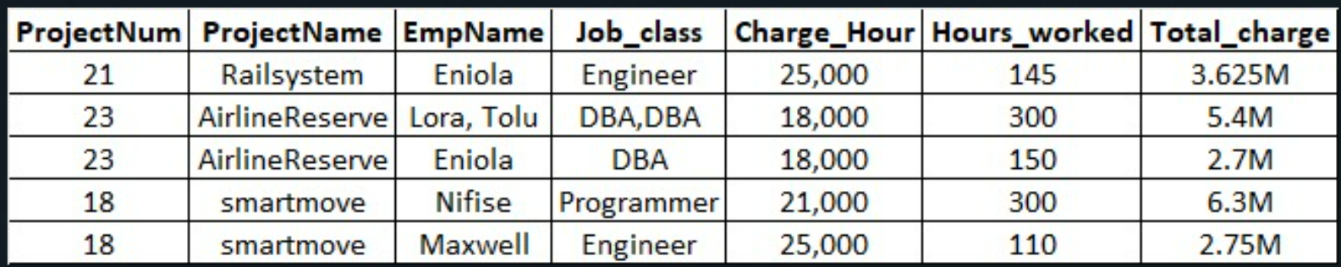
- Identify the Normal Form (NF) the relation is currently. (1mark)
- Normalize to Boyce-Codd Normal Form (BCNF). Provide detailed steps for the normalization process. (8marks)
- What do you understand by the term referential integrity? (2marks)

Question 2:
Study the following schema and answer the questions that follows:
Emp(eid: integer, ename: string, age: integer, salary: real)
Works(eid: integer, did: integer, pct time: integer)
Dept(did: integer, dname: string, budget: real, managerid: integer)
- Write the SQL statements required to create the above relations, including appropriate primary and foreign key integrity constraints. (5marks)
- Define the Dept relation in SQL so that every department is guaranteed to have a manager. (2marks)
- Write an SQL statement to give every employee a 10% raise. (2marks)
- i) Write an SQL statement to delete the ‘Toy’ department. (2 marks)
ii) Given the referential integrity constraints you chose for this schema, explain what happens when this statement is executed. (4 marks)
Question3:
- Company A recently bought company B. The two companies want to integrate their databases. Indicate three challenges that the integration will face. For each challenge give a concrete example. (6 marks)
- In a banking system, consider a scenario where a customer initiates a fund transfer from their savings account (Account A) to their current account (Account B) through an online banking platform. This process includes debiting a specific amount from Account A and crediting an identical amount to Account B. Explain how this situation illustrates the ACID properties of a transaction and elucidate the importance of each property in upholding the transaction's reliability, consistency, and integrity within the banking system. (8 marks)
- What is the difference between a candidate key and a primary key. (1 mark)
Question 4:
Consider the following BCNF relation, which lists the ids, types (e.g., nuts or bolts), and costs of various parts, along with the number available or in stock: Parts (pid, pname, cost, num avail)
You are told that the following two queries are extremely important:
- Find the total number available by part type, for all types. (That is, the sum of the num avail value of all nuts, the sum of the num avail value of all bolts, and so forth)
- List the pids of parts with the highest cost.
- In your physical design for this relation, what kind of a file structure would you choose for the set of Parts records, and what indexes would you create? (6marks)
- Suppose your customers subsequently complain that performance is still not satisfactory (given the indexes and file organization you chose for the Parts relation in response to (a). Since you cannot afford to buy new hardware or software, you have to consider a schema redesign. Explain how you would try to obtain better performance by describing the schema for the relation(s) that you would use and your choice of file organizations and indexes on these relations. (6marks)
- How would your answers to the two questions above change, if at all, if your system did not support indexes with multiple-attribute search keys? (3marks)

MARKING SCHEME
Answer 1:
- 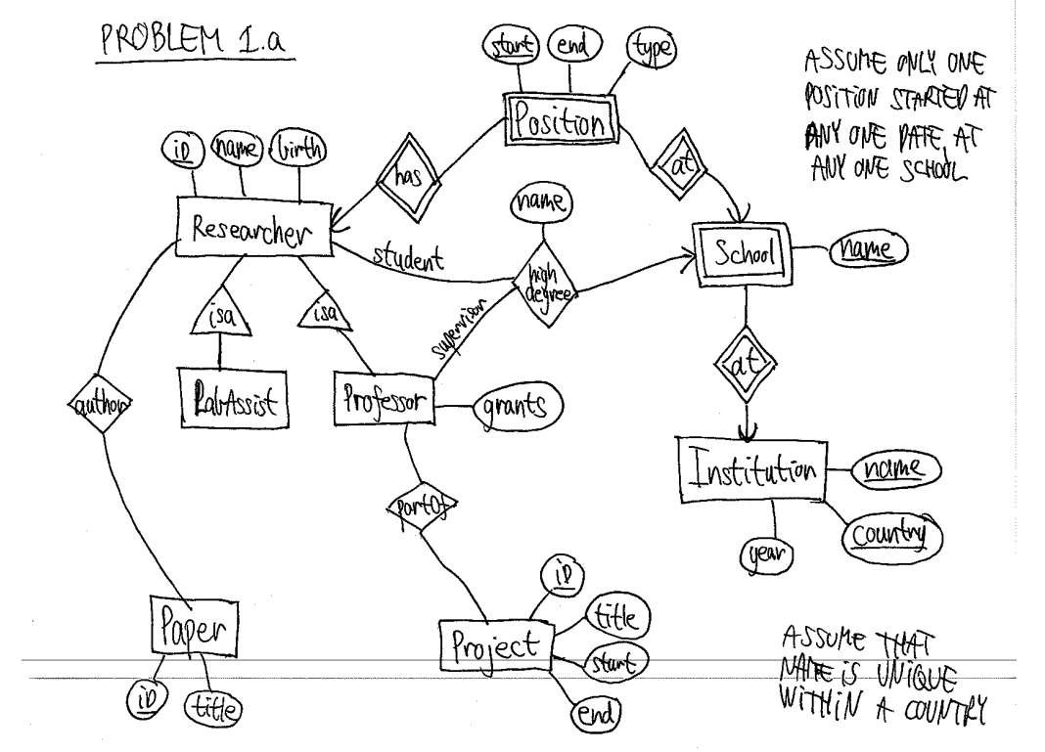
i. False ii.False iii. True iv. False v. False
- functional dependency refers to a relationship between attributes (columns) within a relational database table. It signifies a dependency between two sets of attributes, where the value of one attribute (or a set of attributes) uniquely determines the value of another attribute (or a different set of attributes) within the same table.
- The table is currently in its UN-normalized form
Given the table R, let's identify functional dependencies:
Project_num → Projectname -- Partial
EmpName → Job_class ---Partial
Job_class → charge_Hour --- Transitive
To 1NF - Remove Repeating groups
To 2NF - Eliminate Partial Dependence
To 3NF - Eliminate Transitive dependence
To BCNF- There is no non-key to key; so our 3NF is same as BCNF.
- Referential Integrity ensures the accuracy and consistency of relationships between tables in a relational database. It is maintained through a set of rules or constraints defined on the relationships between tables. The primary objective of referential integrity is to maintain the consistency of data throughout the database.

Answer 2:
- CREATE TABLE Emp (
eid INTEGER PRIMARY KEY,
ename VARCHAR(50),
age INTEGER,
salary REAL
);
-- Creating the Works table
CREATE TABLE Works (
eid INTEGER,
did INTEGER,
pct_time INTEGER,
FOREIGN KEY (eid) REFERENCES Emp(eid),
FOREIGN KEY (did) REFERENCES Dept(did),
PRIMARY KEY (eid, did)
);
-- Creating the Dept table
CREATE TABLE Dept (
did INTEGER PRIMARY KEY,
dname VARCHAR(50),
budget REAL,
managerid INTEGER,
FOREIGN KEY (managerid) REFERENCES Emp(eid)
);
- CREATE TABLE Dept (
did INTEGER PRIMARY KEY,
dname VARCHAR(50),
budget REAL,
managerid INTEGER NOT NULL,
FOREIGN KEY (managerid) REFERENCES Emp(eid)
);
- UPDATE Emp
SET salary = salary * 1.1;
- i) DELETE FROM Dept
WHERE dname = 'Toy';
ii) For Null Assignment
Restrict Deletion: If the foreign key constraint restricts deletion when a manager is associated with the 'Toy' department, the deletion will be prevented, ensuring that the department with a manager cannot be deleted directly.
Set Null: If the foreign key constraint specifies setting managerid to NULL upon deletion, the manager's reference in the 'Toy' department would be removed (set to NULL), but the 'Toy' department record itself would be deleted.
And for cascade deletion.
Associated Works Records: If there are associated records in the Works table (linking employees to the 'Toy' department), those records might also be deleted, depending on the specified constraints.
Manager's Records: If the department manager's employee record in the Emp table is permitted to be deleted, it might also be deleted if the CASCADE option is in place.
Answer 3:
- Multiple solutions were possible including:
• DBMS heterogeneity: e.g., one company stores its data in a relational system while the other one uses a semi-structured system.
• Schema heterogeneity: e.g., in one database the employee information can be stored in one table, while it can be spread across multiple tables in the other database.
• Data type heterogeneity: e.g., unique employee identifiers can be strings in one database and integers in the other.
• Value heterogeneity: e.g., the “cashier” position in one database could be called “associate” in the other database.
• Semantic heterogeneity: e.g., the salary for an employee can be recorded as an hourly before tax value in one database and as a weekly, after-tax value with lunch allowance in the other database.
- Atomicity: The fund transfer transaction is atomic, meaning it's treated as a single unit. Either the entire transaction of debiting from Account A and crediting to Account B occurs completely, or none of it happens. This ensures that if one part fails, the entire transaction is rolled back, maintaining data consistency and preventing partial transfers.
Consistency: Throughout the transaction, the system maintains consistency in the balances of both Account A and Account B. It ensures that the total amount remains unchanged before and after the transaction, preserving the integrity of the data and adhering to defined rules (say overdrafts).
Isolation: The transaction is processed independently of other concurrent transactions. Even if multiple transfers are happening simultaneously, the system ensures that each transaction is isolated and doesn't interfere with others. This prevents issues like concurrency problems or conflicts.
Durability: Once the transaction is successfully completed, the changes made to Account A and Account B are permanent and will persist even in the event of system failure. The system ensures durability by permanently storing the updated balances, safeguarding against data loss or inconsistencies in the long term.
c. While all primary keys are candidate keys, not all candidate keys are necessarily primary keys. The primary key is selected from the available candidate keys to uniquely identify records within a table and has additional constraints (uniqueness and non-null values) compared to general candidate keys.
Answer 4:
- A heap file structure could be used for the relation Parts. A dense unclustered B+Tree index on pname, num avail and a dense unclustered B+ Tree index on cost, pid can be created to efficiently answers the queries
- The problem could be that the optimizer may not be considering the index only plans that could be obtained using the previously described schema. So we can instead create clustered indexes on pid, cost and pname, num avail. To do this we have to vertically partition the relation into two relations like Parts1( pid,cost ) and Parts2( pid, pname, num avail). (If the indexes themselves have not been implemented properly, then we can instead use sorted file organizations for these two split relations).
- If the multi attribute keys are not allowed then we can have a clustered B+ Tree indexes on cost and on pname on the two relations

